1. Write an application to calculate the bill of a cellular service customer depending upon on his/her usage. The following calculates ‘Bill’ as per ‘Usage’ with the following rules applicable. If ‘Bill’ is more than $100, 10% discount is given. Perform data flow testing for all variables. Determine the output using test suite for variables.

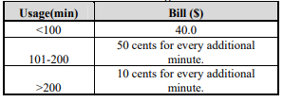

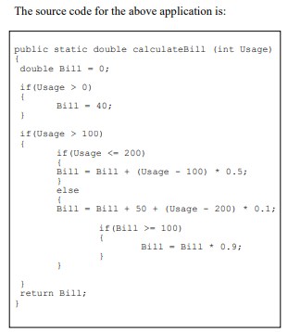

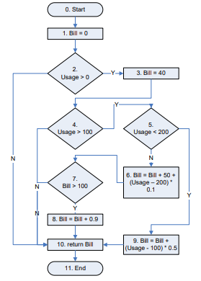

**Data-flow testing paths for each variable**

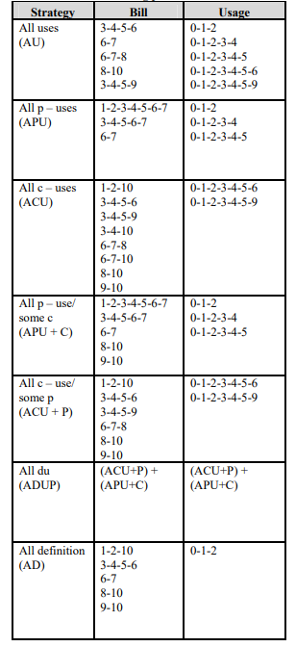

**Test Suite for variable ‘Bill’**

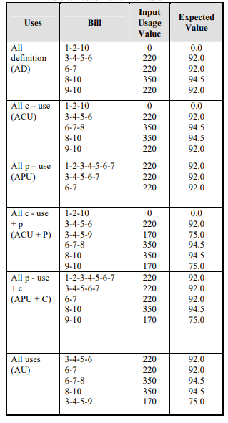

**Test Suite for variable ‘Usage’**

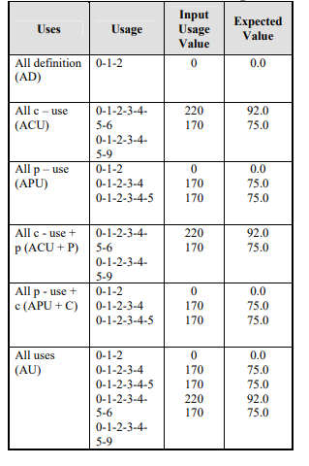

2. For the code given below perform data flow testing for all variables. Determine the output using test suite for variables.

public static void computeStats (int [ ] numbers)

{

int length = numbers.length;

double med, var, sd, mean, sum, varsum;

sum = 0.0;

for (int i = 0; i < length; i++)

{

sum += numbers [ i ];

}

med = numbers [ length / 2 ];

mean = sum / (double) length;

varsum = 0.0;

for (int i = 0; i < length; i++)

{

varsum = varsum + ((numbers [ i ] - mean) * (numbers [ i ] - mean));

}

var = varsum / ( length - 1 );

sd = Math.sqrt ( var );

System.out.println ("length: " + length);

System.out.println ("mean: " + mean);

System.out.println ("median: " + med);

System.out.println ("variance: " + var);

System.out.println ("standard deviation: " + sd);

}

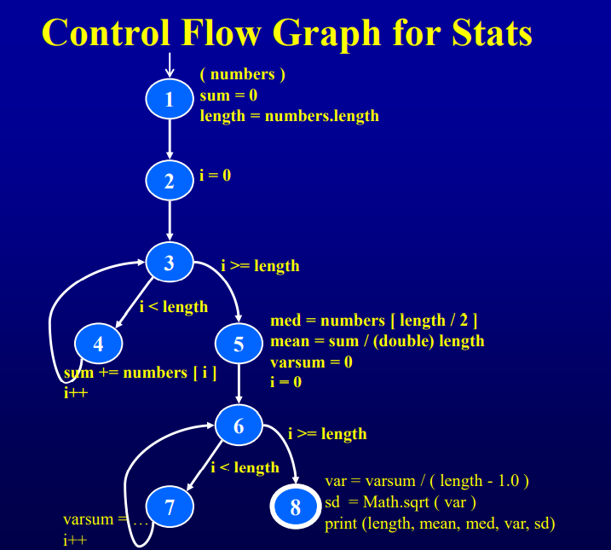

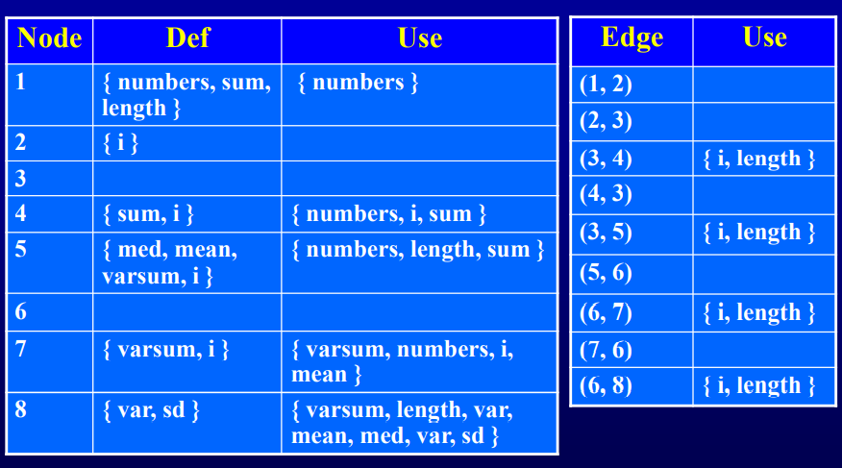

|  |  |
| --- | --- |
| Variable | DU paths |
| numbers | **[ 1, 2, 3, 4 ]**  **[ 1, 2, 3, 5 ]**  **[ 1, 2, 3, 5, 6, 7 ]** |
| length | **[ 1, 2, 3, 5 ]**  **[ 1, 2, 3, 5, 6, 8 ]**  **[ 1, 2, 3, 4 ]**  **[ 1, 2, 3, 5, 6, 7 ]**  **[ 1, 2, 3, 5, 6, 8 ]** |
| med | **[ 5, 6, 8 ]** |
| var | **No path needed** |
| sd | **No path needed** |
| sum | **[ 1, 2, 3, 4 ]**  **[ 1, 2, 3, 5 ]**  **[ 4, 3, 4 ]**  **[ 4, 3, 5 ]** |
| mean | **[ 5, 6, 7 ]**  **[ 5, 6, 8 ]** |
| varsum | **[ 5, 6, 7 ]**  **[ 5, 6, 8 ]**  **[ 7, 6, 7 ]**  **[ 7, 6, 8 ]** |
| i | **[ 2, 3, 4 ]**  **[ 2, 3, 5 ]**  **[ 4, 3, 4 ]**  **[ 4, 3, 5 ]**  **[ 5, 6, 7 ]**  **[ 5, 6, 8 ]**  **[ 7, 6, 7 ]**  **[ 7, 6, 8 ]** |

**// generate test suite for variables similar to previous program**